**Design and Implementation of an Online Premium Course Selling Platform entitled “Learn2Earn”: A Comparative Study and User Analysis"**

**Mr. Neeraj Tyagi1, Ritesh Kumar2, Vishesh Kumar3, Priyakshi Sinha4**

[**neeraj.cse@piet.co.in1**](mailto:neeraj.cse@piet.co.in1)**,** [**ritesh28022000@gmail.com2**](mailto:ritesh28022000@gmail.com2)**,** [**vishesh121299@gmail.com3**](mailto:vishesh121299@gmail.com3)**,** [**priyakshisinha0306@gmail.com4**](mailto:priyakshisinha0306@gmail.com4)

*1,2,3,4Department of Computer Science and Engineering Panipat Institute of Engineering and Technology*

**Abstract**:

The rapid growth of online education has led to the emergence of numerous platforms that offer premium courses. However, there is a lack of research focusing on the design and implementation of such platforms. This research paper aims to fill this gap by presenting a comprehensive study and analysis of an online premium course selling platform. The platform is designed to provide a user-friendly interface and a seamless learning experience for students seeking premium educational content. Learning analytics involves the collection and analysis of learner data to gain insights into their behaviour, progress, and learning outcomes. Research examines the use of learning analytics in online course selling platforms to track learner performance, identify areas for improvement, personalize learning experiences, and predict learner success. Studies also address the ethical considerations and privacy concerns associated with data collection and analysis.

**1. Introduction:**

In today's digital age, Learn2Earn is course selling web app build on JavaScript Framework. Frontend is developed using React.js and its backend is developed in Express.js. Mongo DB is used for database part. The main aim of this web app is to provide solution to course selling businesses for their scalability. This website response time is faster than the others website. Learn2Earn is a Full Stack Web Application which are often referred as Frontend + Backend but there’s more to it than just Frontend and Backend. Terms such as security, how much lightweight, fast the application is, even its live on Internet or not means the servers are running your code 24x7 basically, people can access your website any time any-where, A separated Environment for Development and Production. All of this comes under the Full Stack umbrella. This project is made somewhat like a online edtech platform like Unacademy. This Project mimics some of the functionality that we see in online edtech website like a user can Sign in/Signup, can see some course, write review, buy subscription

**2. Literature Review:**

2.1. Online Education and E-Learning Platforms:

Online education has gained significant traction in recent years, leading to the rise of e-learning platforms. These platforms serve as digital marketplaces where educators can sell their courses to learners worldwide. Research in this area explores the effectiveness of online education, the impact of e-learning platforms on traditional education systems, and the advantages of flexible learning environments.

2.2. Business Models for Online Course Selling Platforms:

Studies have examined different business models employed by online course selling platforms. This includes subscription-based models, where learners pay a recurring fee for access to a library of courses, as well as individual course purchase models. Research investigates the profitability, sustainability, and customer acquisition strategies associated with these business models

2.3. Platform Features and User Experience:

Research has focused on identifying and evaluating the key features of successful online course selling platforms. These features may include a user-friendly interface, intuitive course search and navigation, personalized recommendations, social learning features, interactive assessments, and progress tracking. Studies assess the impact of these features on user engagement, satisfaction, and learning outcomes.

**3. Methodology:**

Building an online premium course selling platform requires careful planning and execution. These are some steps which will be used;

3.1. Identify your target audience:

Determine who your ideal customers are and what type of courses they are looking for. Consider factors such as their interests, educational background, and professional goals.

3.2. Create compelling course content:

Develop high-quality course content that provides value and meets the needs of your target audience. This can include videos, text-based lessons, quizzes, assignments, and supplementary resources. Ensure that the content is engaging, well-structured, and easily digestible.

3.3. Design an intuitive platform:

Create a user-friendly platform that offers a seamless learning experience. Pay attention to the platform's layout, navigation, and overall design to make it visually appealing and easy to use. Consider incorporating features such as progress tracking, discussion forums, and certificates of completion.

3.4. Build a secure payment system:

Implement a reliable and secure payment gateway to handle transactions on your platform. This will allow users to purchase courses easily and provide a smooth checkout experience. Ensure that the payment system is compliant with relevant data protection and privacy regulations.

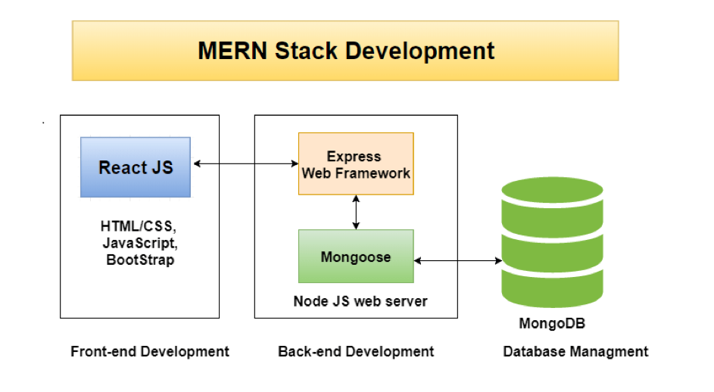

**4. Platform Design and Features:**

4.1. User-Friendly Interface:

* Clean and intuitive design with easy navigation.
* Responsive layout for seamless user experience across devices.
* Clear call-to-action buttons for sign-up, course purchase, and account management.

4.2. Course Catalogue:

* Well-organized course catalogue with categories, filters, and search functionality.
* Course listings with attractive visuals, titles, descriptions, and instructor details.
* Highlight key features, learning outcomes, and target audience for each course.
* Provide a preview or sample lesson to give users a glimpse of the course content.

4.3. Course Pricing and Discounts:

* Flexible pricing options (one-time payment, instalments plan, subscription, etc.).
* Ability to offer discounts, coupon codes, and promotional campaigns.
* Provide clear information about what's included in each pricing tier.

4.4. Secure Payment Gateway:

* Integration with reputable payment gateways to facilitate secure transactions.
* Support for various payment methods (credit/debit cards, PayPal, etc.).
* Ensure the platform is compliant with data protection and privacy regulations.

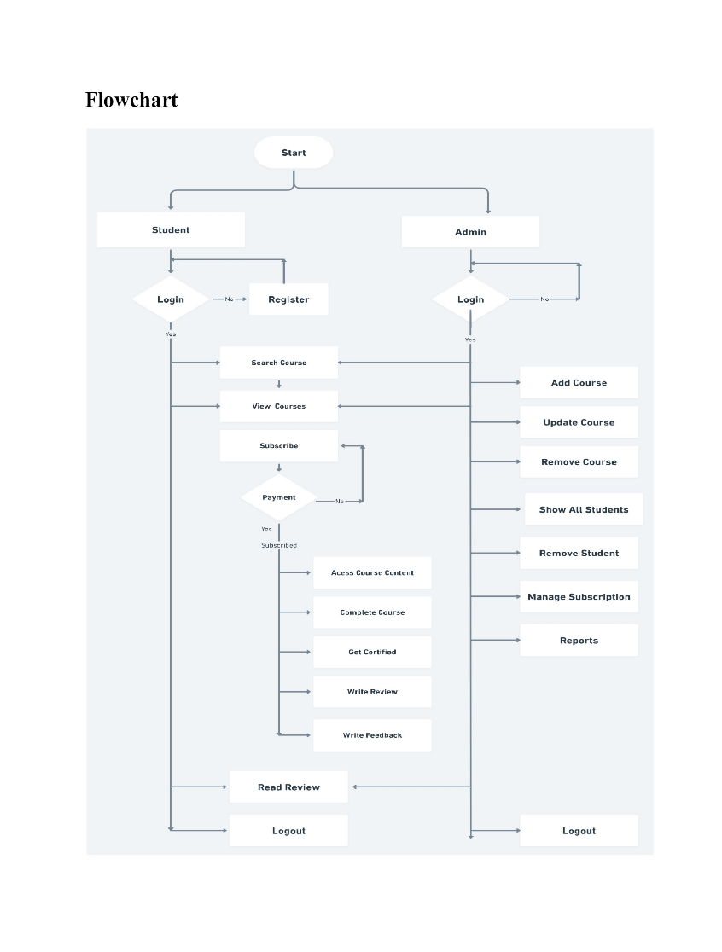

**5. Security and Privacy:**

When it comes to security and privacy in an online premium course selling platform, there are several important considerations to keep in mind. Here are some key aspects to focus on:

5.1. Secure User Authentication:

Implement a robust user authentication system that ensures only authorized individuals can access the platform. This can include features such as strong passwords, two-factor authentication, and secure password storage techniques like hashing and salting.

5.2. Secure Payment Processing:

If your platform handles payments directly, it's crucial to prioritize the security of financial transactions. Utilize reputable and secure payment gateways that comply with industry standards for encryption and data protection. Avoid storing sensitive payment information on your platform and instead rely on tokenization or other secure methods.

**6. Conclusion:**

The online premium course selling platform has emerged as a popular and lucrative business model in recent years. As we conclude our analysis of this platform, several key points can be made. Online premium course platforms have revolutionized education by providing individuals with access to high-quality courses from anywhere in the world. Students can learn at their own pace and on their own schedule, which has significantly increased convenience and flexibility.To succeed in a competitive market, premium course platforms prioritize high-quality content production. This includes well-structured curriculum, engaging video lessons, interactive quizzes, and supplementary materials. The production values of these courses are often on par with or even surpass traditional educational institutions.

**10. References**

1. Udemy: Udemy is one of the largest online learning platforms that allows instructors to create and sell courses on various subjects. It offers a wide range of courses and has a user-friendly interface for both instructors and students. Website: https://www.udemy.com/

2. Coursera: Coursera is an online learning platform that partners with top universities and organizations to offer a variety of courses and specializations. It allows instructors to create and sell courses, and students can earn certifications upon completion. Website: https://www.coursera.org/

3. Teachable: Teachable is a platform that enables instructors to create and sell online courses. It provides a robust set of tools for course creation, customization, and marketing. Teachable also offers options for hosting and managing course content. Website: https://teachable.com/